**CENWP-OD-B 06 July 2022**

**MEMORANDUM FOR THE RECORD**

**SUBJECT: 22BON032 MFR Pacific Lamprey Washington Shore Tube Trap Mortality**

On the morning of Wednesday, 6 July 2022, Columbia River Inter-Tribal Fish Commission (CRITFC) staff found one Pacific Lamprey mortality in one of the Washington Shore tube traps. The fish was collected at Bonneville Dam on 6 July for the CRITFC-Tribal translocation program. The cause of death is unknown, the fish showed no injuries or external indication of disease. Photos of the fresh mortality were taken at the time of removal from the trap and are attached. The individual was frozen for potential future pathogen evaluation.

1. 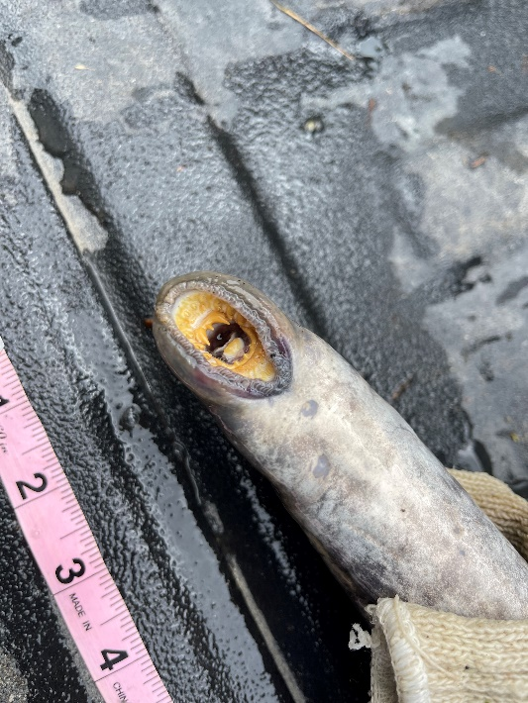Species – Pacific Lamprey (*Entosphenus tridentatus*)
2. Origin – unknown
3. Length – 25.75”
4. Marks and tags – none
5. Marks and Injuries found on carcass – none
6. Cause and Time of Death – unknown
7. Future and Preventative Measures – none

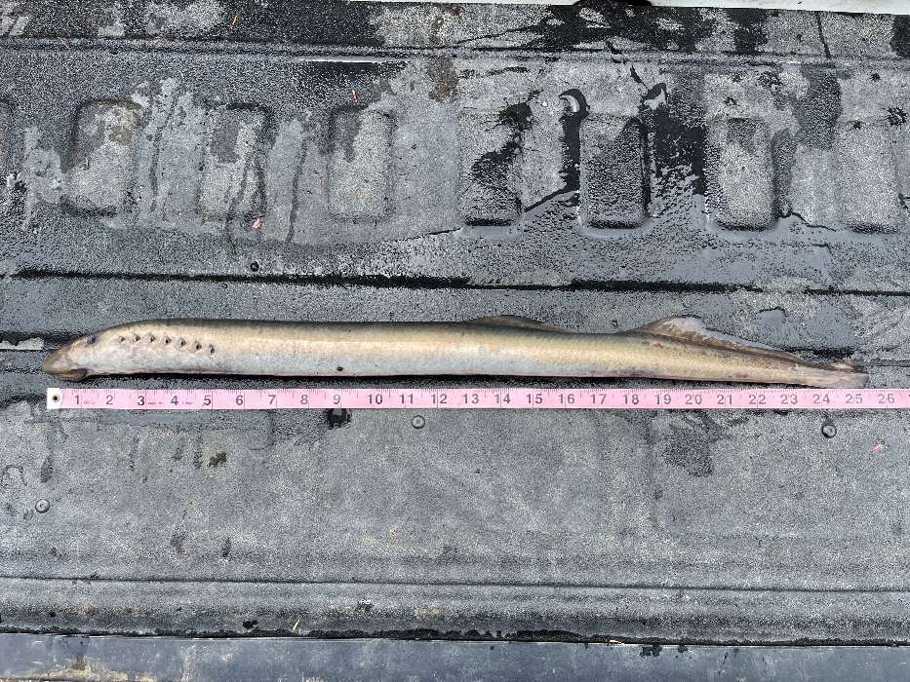

*.*

Sincerely,

Bonneville Project Fisheries